CPE301 – SPRING 2019

Design Assignment 2A

Student Name: David Flores

Student #: 2000881655

Student Email: flored6@unlv.nevada.edu

Primary Github address: https://github.com/David-Floress/submission_da.git

Directory: : https://github.com/David-Floress/submission_da

Submit the following for all Labs:

1. In the document, for each task submit the modified or included code (only) with highlights and justifications of the modifications. Also, include the comments.
2. Use the previously create a Github repository with a random name (no CPE/301, Lastname, Firstname). Place all labs under the root folder ESD301/DA, sub-folder named LABXX, with one document and one video link file for each lab, place modified asm/c files named as LabXX-TYY.asm/c.
3. If multiple asm/c files or other libraries are used, create a folder LabXX-TYY and place these files inside the folder.
4. The folder should have a) Word document (see template), b) source code file(s) and other include files, c) text file with youtube video links (see template).

1. **COMPONENTS LIST AND CONNECTION BLOCK DIAGRAM w/ PINS**

Atmega328p

Multi Function Shield

Micro USB cable

PB5 ,PB4 ,PB3 ,PB2

C2, C3, C4, C5

PB2 and PC2 were used on ATmega328p and Arduino

1. **INITIAL/MODIFIED/DEVELOPED CODE OF TASK 1/A**

;

; DA2A.asm

;

; Created: 3/2/2019 12:15:47 AM

; Author : David Flores

;

; Replace with your application code

.CSEG

.org 0x0000

LDI R16,0b0001_00 ;representing PB5

OUT DDRB, R16 ;enable PB5 as output

LDI R17,0 ;used to set or reset PB5

LDI R20,5 ;set clock prescaler to 1024

STS TCCR1B,R20 ;store value of R20 into TCCR1B

begin:

LDI R20,0x00 ;resets the counter to 0

STS TCNT1H,R20 ;stores value of R20 into TCNT1H

STS TCNT1L,R20 ;stores value of R20 into TCNT1L

RCALL delay1 ;calls timer to wait for 0.435 sec

EOR R17,R16 ;XOR Registers to toggle LED

OUT PORTB,R17 ;Sends value of R17 into PORTB

LDI R20,0x00 ;resets the counter to 0

STS TCNT1H,R20 ;stores the higher bits of value in R20 into TCNT1H

STS TCNT1L,R20 ;stores the lower bits of value of R20 into TCNT1L

RCALL delay2 ;calls timer to wait for 0.29 sec

EOR R17,R16 ;XOR registers to toggle led

OUT PORTB,R17 ;Sends value of R17 into PORTB

RJMP begin ;repeat main loop

delay1:

LDS R29, TCNT1H ;loading upper bit of counter to R29

LDS R28, TCNT1L ;loading lower bit of counter to R28

CPI R28,0x8C ;comparing if lower 8 bits of timer is 0x08

BRSH body1 ;if lower bits of timer have reached desired amount, check the upper bits

RJMP delay1 ;otherwise, keep checking lower bits

body:

CPI R29,0x1A ;check to see if upper timer bits have reached the desired value

BRLT delay1 ;if not, recheck the lower bits

RET ;once the timer reached the desired value, toggle the LED

delay2:

LDS R29, TCNT1H ;loading upper bit of counter to R29

LDS R28, TCNT1L ;loading lower bit of counter to R28

CPI R28,0b10110010 ;comparing if lower 8 bits of timer

BRSH body1 ;if lower bits of timer have reached desired amount, check the upper bits

RJMP delay2 ;otherwise, keep checking lower bits

body1:

CPI R29,0b01000110 ;check to see if upper bits of the timer has reached the desired value

BRLT delay2 ;if not, recheck the lower bits

RET ;once the timer reached the desired value, toggle the LED

**C CODE 1/A:**

/*

* GccApplication1.c

*

* Created: 3/4/2019 8:19:41 PM

* Author : David Flores

*/

#include <avr/io.h>

//C Code Part 1

#include <avr/io.h>

#include <stdio.h>

int main(void)

{

DDRB = (1<<2); //PB2 sets to 1

TCCR1B = 5; //prescaler set to 5

while(1) //loops continously forever

{

TCNT1 = 0; //T count equals 0

while (TCNT1 != 4530){} //T count till 40%

PORTB ^= (1<<2); //Produces toggle

TCNT1 = 0; //T count equals 0

while (TCNT1 != 6796){} //T count till 60%

PORTB ^= (1<<2); //Produces toggle

}

return 0;

}

1. **DEVELOPED MODIFIED CODE OF TASK 2/A from TASK 1/A**

;

; Part2Assembly.asm

;

; Created: 3/4/2019 8:23:54 PM

; Author : David Flores

;

; Replace with your application code

//Part 2

.org 0x0000

LDI R16, 0xFF ;representing PB5

OUT DDRB, R16 ;enable PB5 as output

LDI R17,0 ;used to set or reset PB5

CBI DDRC, 2 ;enable PC2 as input

LDI R20,5 ;set clock prescaler to 1024

STS TCCR1B, R20 ;send prescaler

LOOP1:

LDI R18, 0b111100 ;loads value into R18

OUT PORTB, R18 ;sends value of R18 into PORTB

SBIC PINC, 2 ;make pin C2 an input

RJMP NOTPUSHED ;RJMP to NOTPUSHED

LDI R18, 0b111000 ;loads value into R18

OUT PORTB, R18 ;sends value of R18 into PORTB

LDI R20, 0 ;Loads 0 into R20

STS TCNT1H, R20 ;stores the higher bits of value in R20 into TCNT1H

STS TCNT1L,R20 ;stores the lower bits of value of R20 into TCNT1L

RCALL DELAY1 ;Calls the subroutine

RJMP LOOP1 ;RJMP to LOOP1

NOTPUSHED:

SBI PORTB, 2 ;set bit 2 to portB

RJMP LOOP1 ;RJMP LOOP1

DELAY1:

LDS R29, TCNT1H ;loading upper bit of counter to R29

LDS R28, TCNT1L ;loading lower bit of counter to R28

CPI R28,0x4A ;comparing if lower 8 bits of timer is 0x08

BRSH BODY1 ;if lower bits of timer have reached desired amount, check the upper bits

RJMP DELAY1 ;otherwise, keep checking lower bits

BODY1:

CPI R29,0x4C ;check to see if upper timer bits have reached the desired value

BRLT DELAY1 ;if not, recheck the lower bits

RET ;once the timer reached the desired value, toggle the LED

**C code part 2:**

//C Code Part 2

#define *F_CPU* 16000000ul

#include <avr/io.h>

#include <stdio.h>

#include <util/delay.h>

int main(void){

DDRB |= (1<<2);

PORTB |= (1<<2); //sets PORTB2 as an input

DDRC &= (0<<2); //

PORTC |= (0<<2); //sets push button to zero

while (1)

{

if (!(PINC & (1 << PINC2)))

{

PORTB &= ~(1<<2);

*_delay_ms*(1250);

}

else

{

PORTB |= (1<<2);

}

}

return 0;

}

1. **SCHEMATICS**

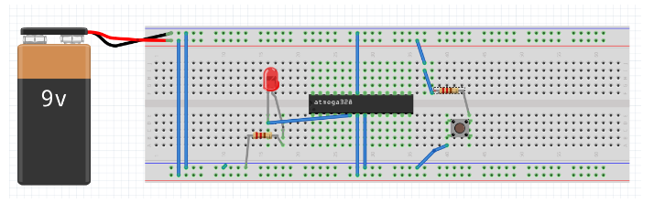

1. **SCREENSHOTS OF EACH TASK OUTPUT (ATMEL STUDIO OUTPUT)**

C Code Part 1 40% Total Period

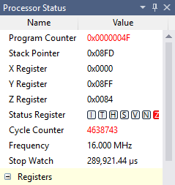 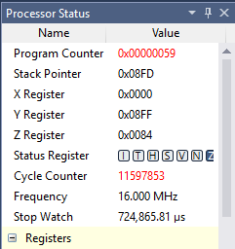

1. **SCREENSHOT OF EACH DEMO (BOARD SETUP)**

Part1:

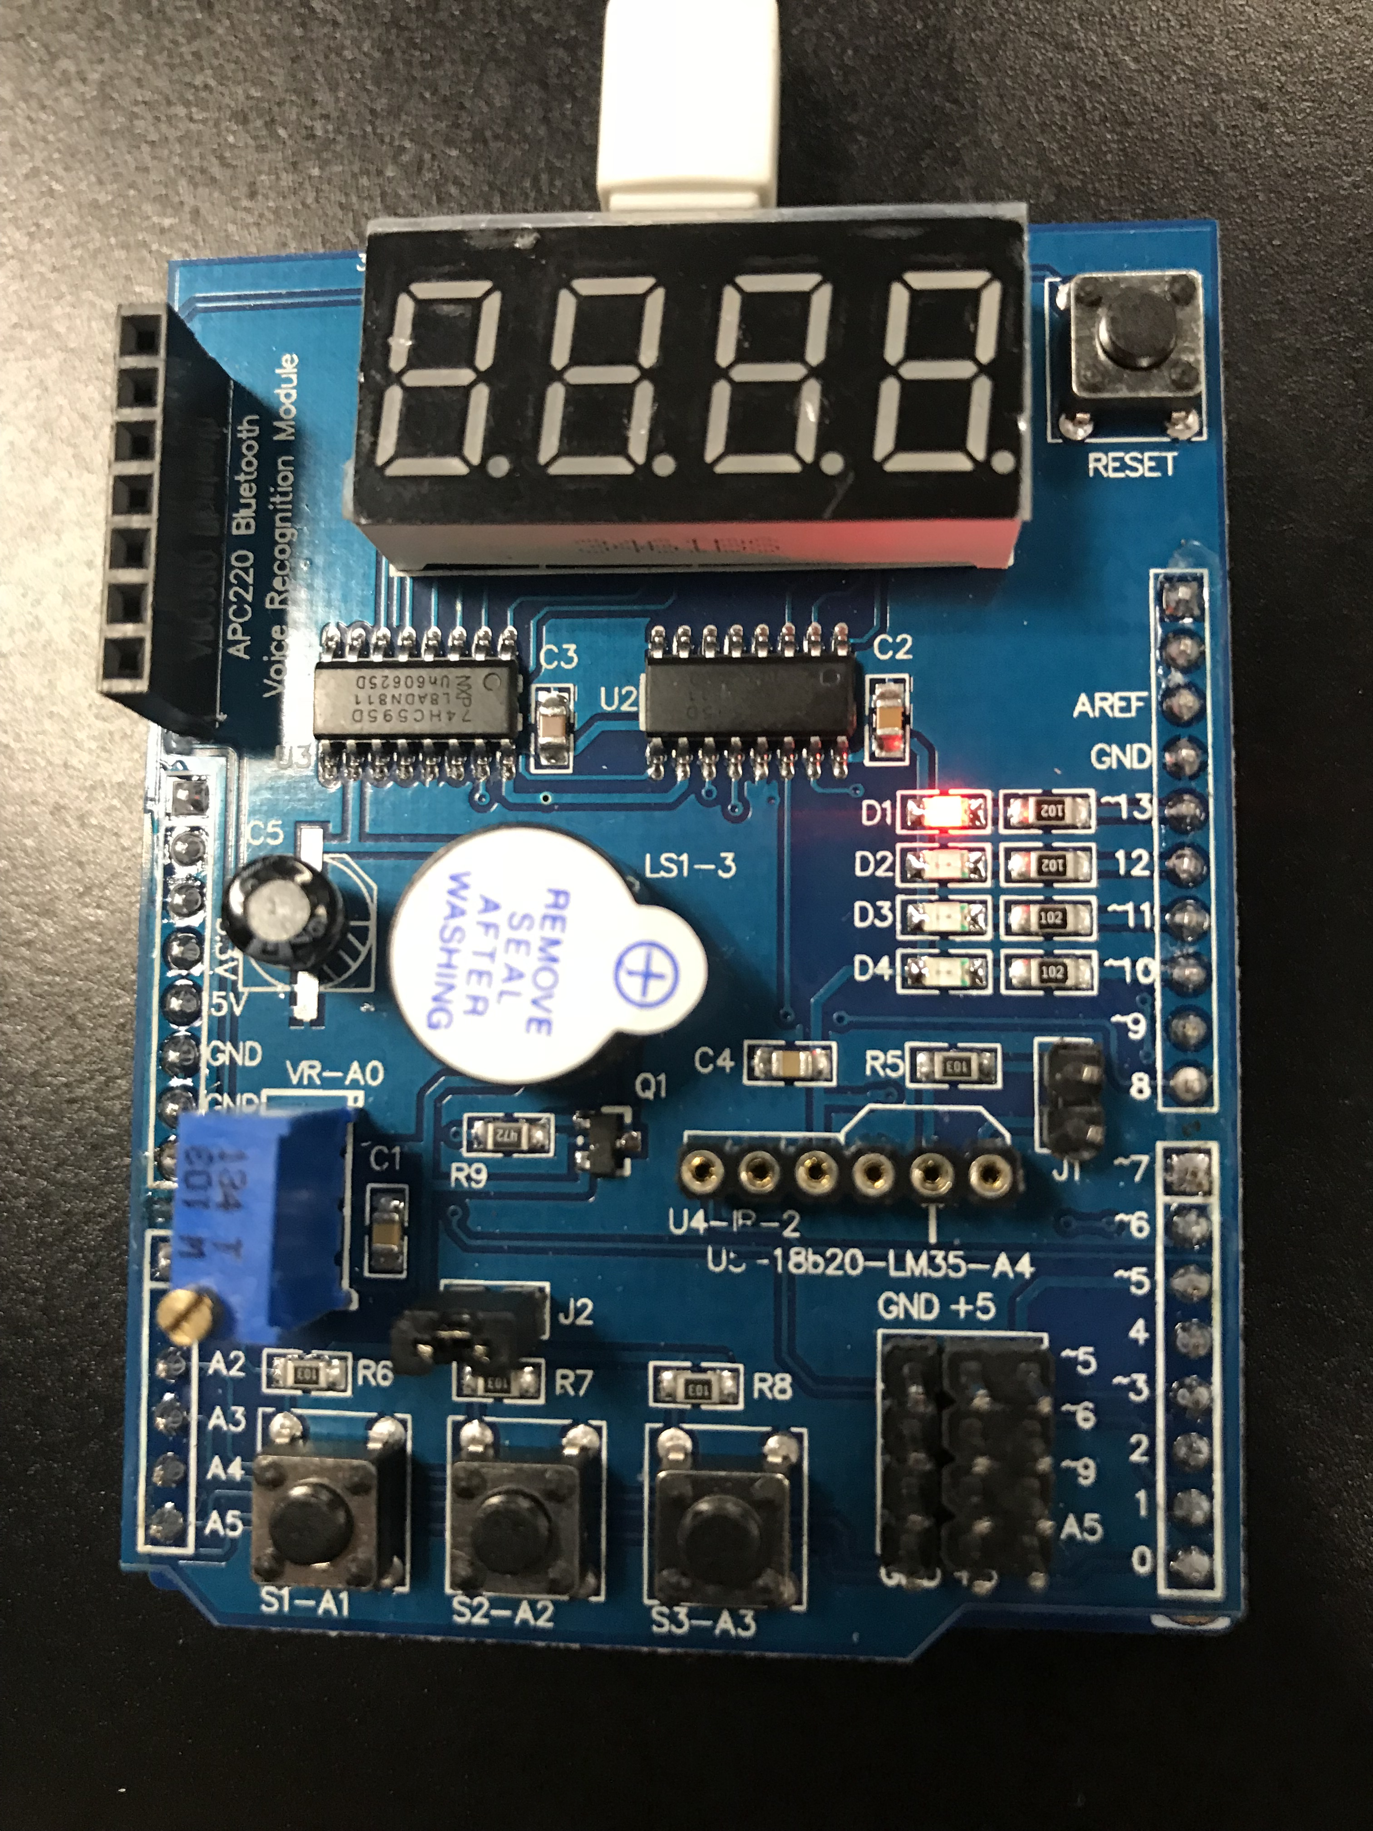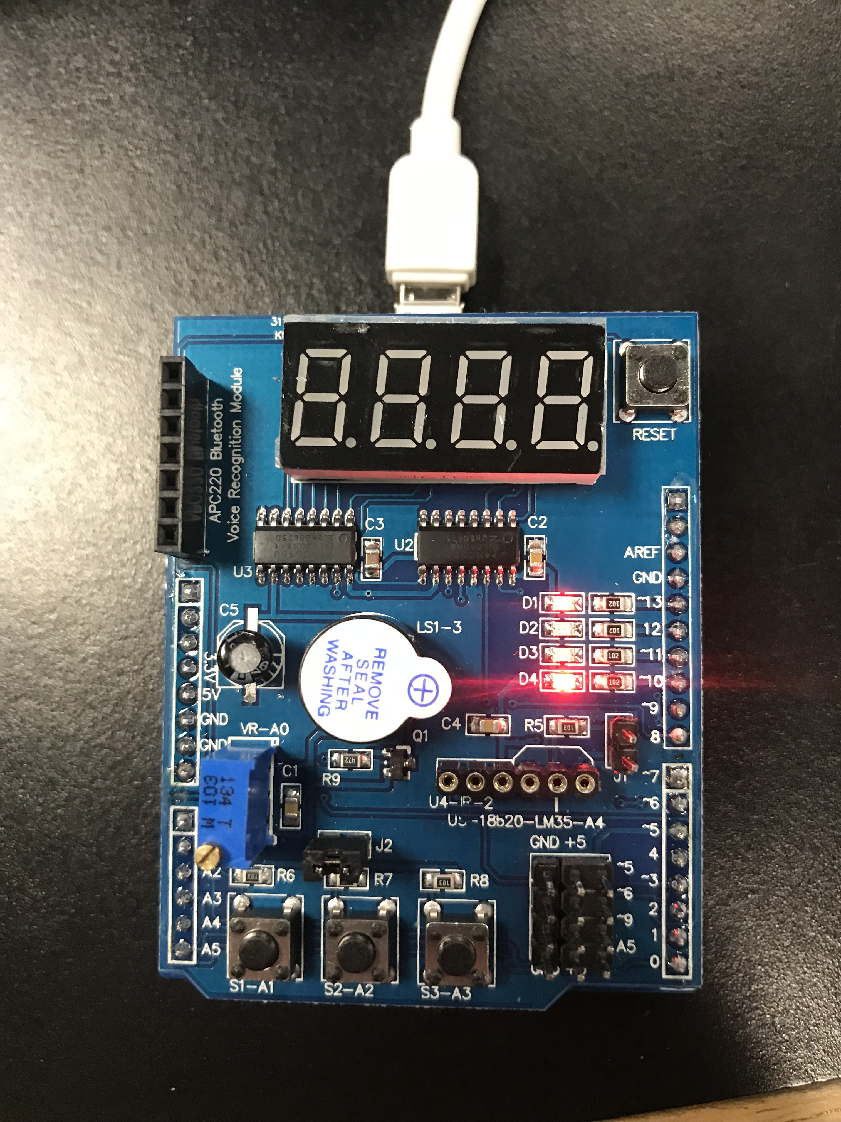

Part2:

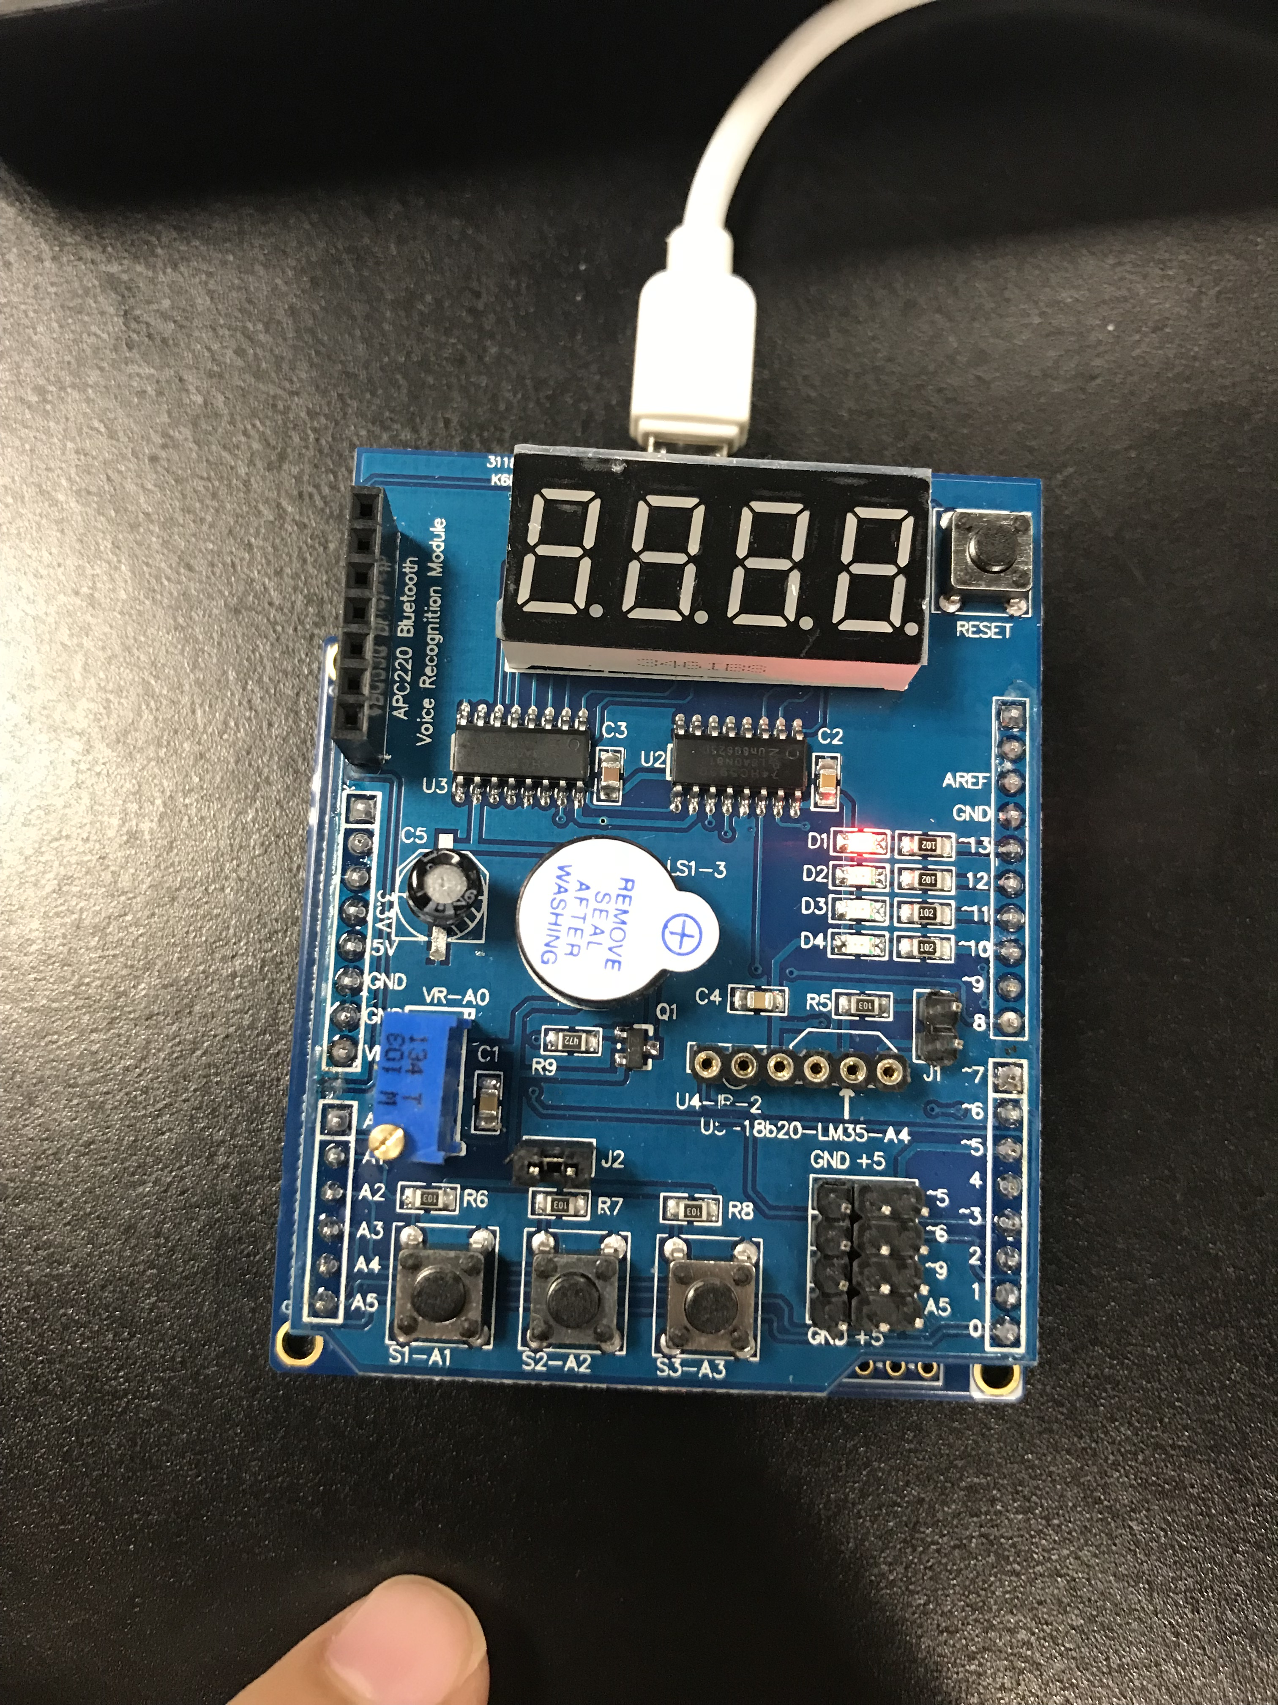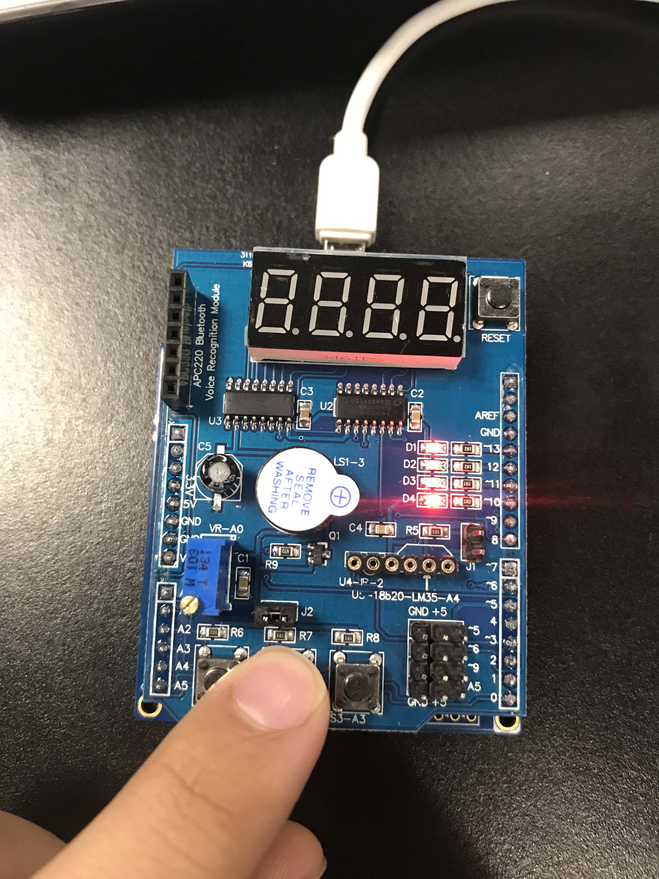

1. **VIDEO LINKS OF EACH DEMO**
2. **GITHUB LINK OF THIS DA**

https://github.com/David-Floress/submission_da.git

**Student Academic Misconduct Policy**

<http://studentconduct.unlv.edu/misconduct/policy.html>

“This assignment submission is my own, original work”.

NAME OF THE STUDENT